Technical Report

Subject: | Determining cold mass position from field map - JLAB Q1 | Author: | SJ
Ref No.: | P0452SPM | Date: | 11/06/15
Dist: | JLAB | CC: | NRS/PNP

Introduction
SJ and TAB visited JLAB to take a field map measurement of the Q1 magnet built by SM. Through harmonic expansion analysis we can determine the magnet position. A cylindrical plotting rig was mounted on the system OVC with 47 planes along z and 64 angular points on each plane. Mathcad was used to write a spreadsheet to calculate the harmonic expansion of any slice (z plane) and do further work analysing the integrated field and field gradient to confirm that the magnet meets specification. The outputs from this spread sheet are compared to the Opera model to find the cold mass position.

Opera script
The plotting rig was mapped by JLAB’s mapping team and found small offsets in its origin compared to the OVC. There are slight differences in the positions of all the slices, perhaps due to sagging of the rig. This also means the plotting radius of different slices varies. A script was written in Opera (Appendix A) to which the offsets, z position and plotting radius of the slice is input. It then plots a circle that represents the 64 measurements on that slice and the fits a Fourier series to these points. This is then output to a text file. Gauss is the unit of magnetic field used everywhere here including the expansion terms.
It has been shown before that different terms of the harmonic expansion vary for different movements and that, for small movements, they are independent of each other. A_2 the dipole sine term depends only on translation in the Y direction, B_2 the dipole cosine term depends only on the translation in the X direction and B_3, the quadrupole cosine term depends on the rotation of the cold mass about Z. By performing Fourier analysis at a few slices we can determine the magnet position in terms of the 6 degrees of freedom.
The Opera script then offsets the measurement circle by a small amount in x and outputs the B_2 term to the text file at each step. It then repeats this for offset in y and rotation about z. Appendix B shows an example of the output file.
The harmonic terms are plotted against their associated offsets. Figure 1 shows the relationship between x displacement and B_2 at the three original slices of interest, which are z=-800, z=0mm and z=800mm, Figure 2 shows the relationship between y displacement and A_2 and Figure 3 shows the relationship between rotation about z and B_3 for these slices.
The lines are essentially parallel but offset along the y axis. This is a result of setting the origin of the measurement circle to coincide with the origin of the corresponding slice on the plotting rig - as measured.
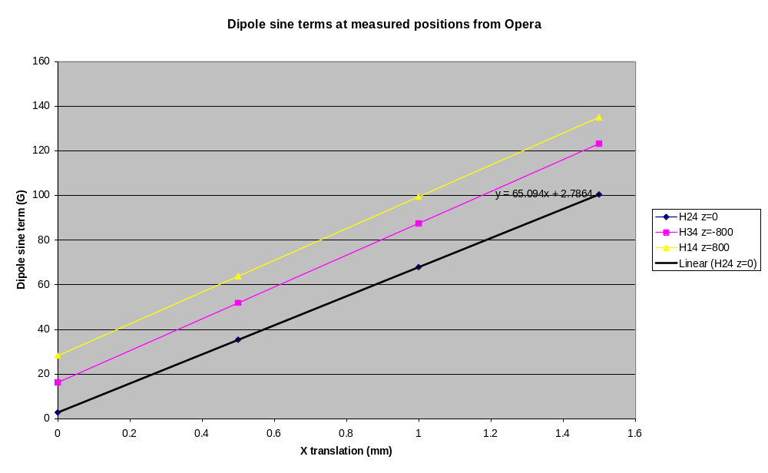
Figure 1
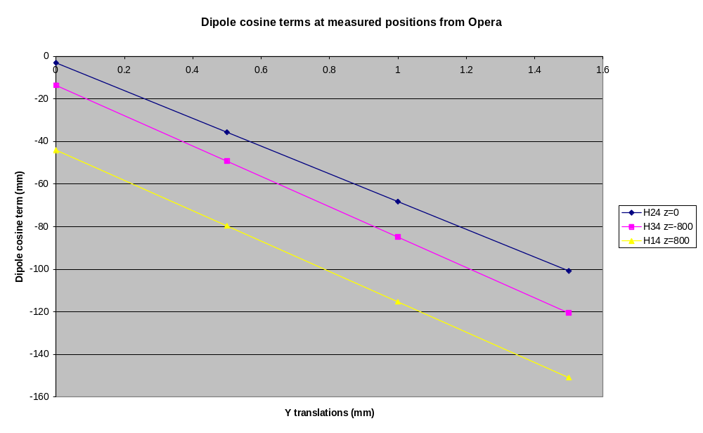
Figure 2
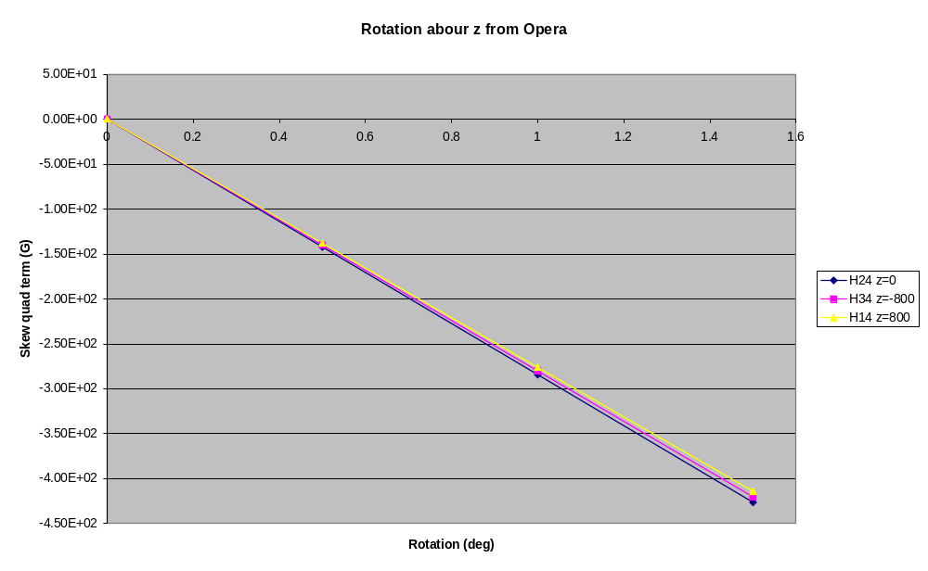
Figure 3

Analysis
As is clear from the Figures above, there is a linear dependence of each of the harmonic terms to translation and rotation about z. By fitting lines to this data we can use the harmonics of the measured data to determine the displacement of the magnet from the mechanical centre. Excel was used to fit lines to the Opera outputs. It should be noted that in Opera the offsets were calculated by moving the “measurement circle”, which is equivalent to keeping the measurement circle fixed and moving the magnet in the opposite direction so to calculate the magnet displacement we must multiply the output by -1. Additionally the magnitude of the main quadrupole terms from the measured data and the Opera outputs differ slightly, perhaps due to BH curve errors used in the model (pretty good match really), and so the other terms of the harmonic expansion are scaled as the ratio of the measured main quadrupole term and the Opera main quadrupole term.
In the end, full angular plots were done on 7 slices - -800mm, -600mm, -375mm, 0mm, 375mm, 600mm and 800mm. The displacements were calculated using the harmonic terms output from the MathCad sheet. We only have the probe position information for the original slices of interest so to calculate the displacements for the other slices, the relationships for z=0mm are used. This is reasonable as the field is flat in the middle and in any case there is not too much variation. The X and Y displacements for each slice are shown in Figure 4 and the z rotations are shown in Figure 5.
There is significant variation in the results and this is most likely to be a result of the inaccuracies of the plotting rig. From the mapping data (Appendix C) it can be seen that the origins of the circles on each slice vary which could explain the variation.
The approximate magnet displacements are x=1.5 ± 0.6 mm and y =1.7 ± 0.5 mm. The data is too noisy to determine whether there is a rotation about x and y but we can say that it is less than asin(0.6/800)=0.043 deg.

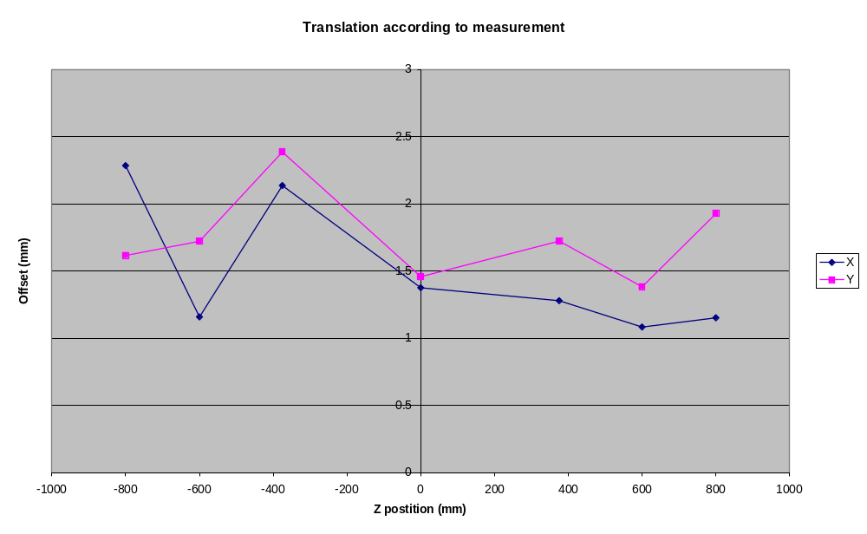
Figure 4
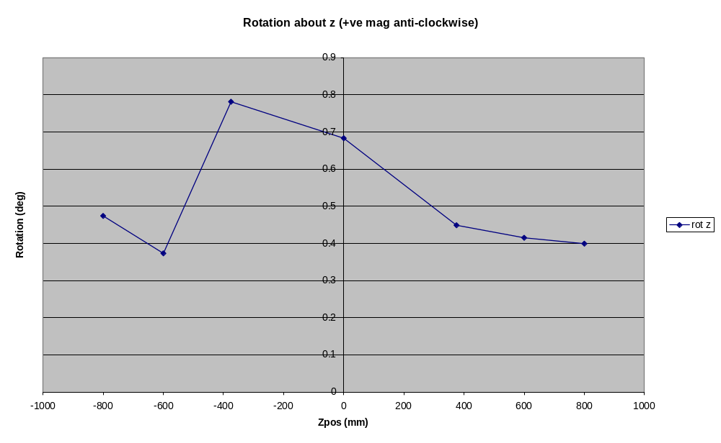
Figure 5
The rotation of the cold mass about z is on average 0.5 deg as measured here. However, the central slice was re-plotted but taking the whole hall probe carriage out and replacing it in reverse. This means that any rotation in the hall probe about z will be reversed. It can be shown that a rotation of the hall probe about Z will be indistinguishable from a rotation of the magnet. The results of this plot using the reversed probe are shown below.
 | Reversed |  | Non reversed
 | Sine | Cosine | Sine | Cosine
Dipole | 101.15 | -83.97 | 89.30 | -84.40
Quadrupole | -7919.61 | -259.04 | -7921.99 | 188.75
x | 1.37 | mm | 1.38 | mm
y | 1.65 | mm | 1.46 | mm
rot z | -0.94 | deg | 0.68 | deg

It is clear that the apparent rotation of the magnet has flipped in the other direction as a result of reversing the hall probe carriage. This shows that the hall probe was not quite straight. It is extremely difficult to accurately measure and set the angle of such a small probe. The average of these 2 measurements is -0.13 deg. There is also scope for the whole carriage to twist as it clicks into its indexing holes and this could explain the large variation along its length.
Ideally the full field plot would be best done twice with the carriage reversed during one measurement. The average of all these could give a fair indication of the true rotation about z.
Taking the average of these two points at z=0mm we can say the rotation about z is 0.13±0.2 deg.

Checking
Finally, to confirm that the analysis method is at least self consistent the calculated offsets for the slice at z=0mm were inserted back into the Opera model. The plot circle command in Opera was used as before, with the calculated cold mass displacements and rotations (multiplied by -1 again as we are moving the plot and not the model) added to the plotting rig offsets for that slice. A Fourier series is then fitted as before and the resulting harmonic terms compared to the input terms. The table below compares the two sets of harmonics.
 | Sine | Cosine | Description
Dipole | 89.30 | -84.40 | Harmonics of measured data
Quadrupole | -7921.99 | 188.75 | Harmonics of measured data
Dipole | 97.00 | -87.96 | Harmonics of Opera circle plot with circle offset by the amounts calculated in this analysis
Quadrupole | -8101.79 | 193.19

There is quite a good match considering the assumptions that are made - predominantly that the terms are independent of each other. Most importantly it shows that the directions are correct.
It should be noted that Opera plots with the anti-clockwise direction as being positive (y pointing up and x pointing right) and we were always doing the plotting in a clockwise direction. An Excel macro was created to easily re-order the data so that MathCad calculates the harmonics in the clockwise direction.

Conclusions
- The magnet is displaced about 1.5 mm in x.
- The magnet is displaced about 1.7 mm in y.
- The rotation about the z axis is estimated to be -0.13 deg but possibly between -0.9 deg and +0.8 deg.
- The rotation about the x and y axis is <0.043 deg.
- The magnet seems to be well positioned with respect to the mechanical bore. The x, y and z displacements can be dealt with most easily by moving the entire system with respect to the beam line and it should be possible to move it these small distances without any interference. The rotation about z is the most uncertain but it is believed that it is likely to be positioned to better than 0.2 deg.
- The risks associated with moving the cold mass within the cryostat combined with the results of these measurements leads me to not recommend attempting to move the cold mass - at least not until a more accurate method of determining the position is used.

Appendix A
$Constant #xoff 0.03953 'X offset in cm'
$constant #yoff -0.06173 'Y offset in cm'
$constant #zoff 80.15067 'Z offset in cm'
$constant #Reff 18.6679 'Radius of hall probe circle at this place'
$String file 'C:\Users\fea2\Desktop\jlab.txt'
$DIALOG START
$FILEPROMPT NAME=file PROMPT='Save info to' LOAD=No
$DIALOG STOP
$OPEN 1 '%filepath[&file&]\%filebasename[&file&].csv' Overwrite
$Assign 1
$Write 1 'Translation X and b2'
$Write 1 'Translation Y and a2'
$Write 1 'Rotation about z and b3'
$CLose 1
$OPEN 1 '%filepath[&file&]\%filebasename[&file&].csv' Append
$constant #xdisp 0 'x displacemtn in cm'
$Constant #ydisp 0 'y displacement in cm'
$constant #zrot 0 'rotation about z in deg'
SET XLOCAL=#xoff+#xdisp YLOCAL=-#yoff+#ydisp ZLOCAL=0 TLOCAL=0,PLOCAL=#zrot+90,SLOCAL=0
CIRCLE RADIUS=#Reff TH1=0 TH2=360 ZC=#zoff NP=63 BUFFER=Circle | PLOT FILE=TEMP COMPONENT=br
FIT TYPE=FOURIER FILE=TEMP COMPONENT=br ORDER=5 PRINT=YES
$Assign 1 1 1
$write 1 ' ' ',' ' '
$write 1 'Main quad' ',' '%real(a_2)'
$write 1 ' ' ',' ' '
$Do #step 0 1.5 0.5
$constant #xdisp #step/10 'x displacemtn in cm'
$Constant #ydisp 0 'y displacement in cm'
$constant #zrot 0 'rotation about z in deg'
SET XLOCAL=#xoff+#xdisp YLOCAL=-#yoff+#ydisp ZLOCAL=0 TLOCAL=0,PLOCAL=#zrot+90,SLOCAL=0
CIRCLE RADIUS=#Reff TH1=0 TH2=360 ZC=#zoff NP=63 BUFFER=Circle | PLOT FILE=TEMP COMPONENT=br
FIT TYPE=FOURIER FILE=TEMP COMPONENT=br ORDER=5 PRINT=YES
$Assign 1 1 1
$write 1 '%real(#step)' ',' '%real(b_1)'
$End Do
$write 1 ' ' ',' ' '
$Do #step 0 1.5 0.5
$constant #xdisp 0 'x displacemtn in cm'
$Constant #ydisp #step/10 'y displacement in cm'
$constant #zrot 0 'rotation about z in deg'
SET XLOCAL=#xoff+#xdisp YLOCAL=-#yoff+#ydisp ZLOCAL=0 TLOCAL=0,PLOCAL=#zrot+90,SLOCAL=0
CIRCLE RADIUS=#Reff TH1=0 TH2=360 ZC=#zoff NP=63 BUFFER=Circle | PLOT FILE=TEMP COMPONENT=br
FIT TYPE=FOURIER FILE=TEMP COMPONENT=br ORDER=5 PRINT=YES
$Assign 1 1 1
$write 1 '%real(#step)' ',' '%real(a_1)'
$End Do
$write 1 ' ' ',' ' '
$Do #step 0 1.5 0.5
$constant #xdisp 0 'x displacemtn in cm'
$Constant #ydisp 0 'y displacement in cm'
$constant #zrot #step 'rotation about z in deg'
SET XLOCAL=#xoff+#xdisp YLOCAL=-#yoff+#ydisp ZLOCAL=0 TLOCAL=0,PLOCAL=#zrot+90,SLOCAL=0
CIRCLE RADIUS=#Reff TH1=0 TH2=360 ZC=#zoff NP=63 BUFFER=Circle | PLOT FILE=TEMP COMPONENT=br
FIT TYPE=FOURIER FILE=TEMP COMPONENT=br ORDER=5 PRINT=YES
$Assign 1 1 1
$write 1 '%real(#step)' ',' '%real(b_2)'
$End Do
$write 1 ' ' ',' ' '
$close 1

Appendix B
Translation X and b2
Translation Y and a2
Rotation about z and b3
Main quad | -8144.64
0 | 2.78646
0.5 | 35.33329
1 | 67.88021
1.5 | 100.4271
0 | -3.11282
0.5 | -35.6607
1 | -68.2071
1.5 | -100.752
0 | 2.11E-04
0.5 | -142.142
1 | -284.243
1.5 | -426.26

Appendix C
Constructed Circle Centers
 | X | Y | Z
PROBE@-800mm | 0.07 | 0.05 | -801.51
Probe@Center | 0.04 | -0.06 | -1.21
PROBE@800mm | 0.04 | 0.04 | 798.89
Probe position at each of the 47 locations along the rail in the top orientation (hole 15)
 | X | Y | Z |  |  | X | Y | Z
H1 | 0.15 | 187.46 | 1448.10 |  | H25 | 0.22 | 186.76 | -126.50
H2 | -0.20 | 187.06 | 1397.85 |  | H26 | 0.23 | 186.52 | -252.06
H3 | -0.41 | 186.81 | 1347.96 |  | H27 | 0.35 | 186.92 | -376.91
H4 | -0.65 | 186.81 | 1298.09 |  | H28 | 0.14 | 186.88 | -501.49
H5 | -0.64 | 186.78 | 1248.07 |  | H29 | 0.25 | 186.62 | -551.76
H6 | -0.82 | 186.59 | 1198.25 |  | H30 | 0.22 | 186.68 | -601.68
H7 | -0.64 | 186.54 | 1148.40 |  | H31 | 0.20 | 186.94 | -651.19
H8 | -0.41 | 186.46 | 1098.29 |  | H32 | 0.19 | 186.90 | -701.36
H9 | -0.45 | 186.47 | 1048.45 |  | H33 | 0.15 | 186.70 | -751.52
H10 | -0.07 | 186.68 | 998.26 |  | H34 | 0.13 | 186.58 | -801.62
H11 | -0.15 | 186.69 | 948.29 |  | H35 | 0.10 | 186.64 | -852.03
H12 | -0.14 | 186.69 | 898.30 |  | H36 | 0.02 | 187.00 | -901.34
H13 | -0.21 | 186.61 | 849.02 |  | H37 | 0.07 | 187.03 | -951.21
H14 | -0.26 | 186.58 | 798.56 |  | H38 | 0.11 | 187.06 | -1001.34
H15 | -0.28 | 186.73 | 748.35 |  | H39 | 0.12 | 187.06 | -1051.51
H16 | -0.15 | 186.77 | 698.11 |  | H40 | 0.10 | 187.05 | -1101.36
H17 | -0.10 | 186.73 | 648.24 |  | H41 | 0.03 | 187.22 | -1151.12
H18 | -0.12 | 186.65 | 598.29 |  | H42 | -0.03 | 187.30 | -1201.13
H19 | -0.20 | 186.19 | 548.23 |  | H43 | 0.02 | 187.45 | -1251.05
H20 | -0.41 | 186.49 | 498.39 |  | H44 | -0.06 | 187.59 | -1300.91
H21 | -0.11 | 186.75 | 373.54 |  | H45 | 0.17 | 187.58 | -1351.21
H22 | -0.57 | 186.39 | 248.21 |  | H46 | 0.09 | 188.01 | -1400.94
H23 | -0.49 | 186.77 | 123.46 |  | H47 | -0.39 | 188.49 | -1450.65
H24 | -0.19 | 186.45 | -1.59
Probe measured at each of the 64 positions in three separate locations
 | X | Y | Z |  |  | X | Y | Z
H1_-8 | -183.03 | 36.52 | 798.68 |  | H1_0 | -183.11 | 36.53 | -1.51
H2_-8 | -178.55 | 54.29 | 798.82 |  | H2_0 | -178.64 | 54.41 | -0.84
H3_-8 | -172.36 | 71.53 | 798.79 |  | H3_0 | -172.45 | 71.56 | -1.55
H4_-8 | -164.62 | 87.95 | 798.96 |  | H4_0 | -164.69 | 88.01 | -0.77
H5_-8 | -155.09 | 103.82 | 798.74 |  | H5_0 | -155.12 | 103.93 | -1.54
H6_-8 | -144.29 | 118.35 | 798.93 |  | H6_0 | -144.30 | 118.56 | -1.27
H7_-8 | -132.05 | 131.88 | 798.76 |  | H7_0 | -132.06 | 131.96 | -1.47
H8_-8 | -118.43 | 144.17 | 798.83 |  | H8_0 | -118.42 | 144.33 | -0.80
H9_-8 | -103.70 | 155.18 | 798.83 |  | H9_0 | -103.69 | 155.26 | -1.45
H10_-8 | -87.95 | 164.59 | 798.97 |  | H10_0 | -87.85 | 164.72 | -0.73
H11_-8 | -71.42 | 172.43 | 798.80 |  | H11_0 | -71.34 | 172.51 | -1.43
H12_-8 | -54.13 | 178.62 | 798.85 |  | H12_0 | -54.12 | 178.62 | -0.62
H13_-8 | -36.52 | 183.01 | 798.79 |  | H13_0 | -36.41 | 183.09 | -1.39
H14_-8 | -18.50 | 185.67 | 798.79 |  | H14_0 | -18.30 | 185.78 | -1.41
H15_-8R | -0.27 | 186.66 | 798.91 |  | H15_0R | -0.17 | 186.68 | -0.69
H16_-8 | 18.57 | 185.75 | 798.78 |  | H16_0 | 18.75 | 185.76 | -1.50
H17_-8 | 36.64 | 183.03 | 798.92 |  | H17_0 | 36.81 | 183.05 | -0.84
H18_-8 | 54.40 | 178.58 | 798.84 |  | H18_0 | 54.62 | 178.55 | -1.56
H19_-8 | 71.42 | 172.49 | 798.93 |  | H19_0 | 71.63 | 172.46 | -0.78
H20_-8 | 88.20 | 164.55 | 798.82 |  | H20_0 | 88.42 | 164.50 | -1.65
H21_-8 | 103.76 | 155.23 | 798.91 |  | H21_0 | 103.94 | 155.15 | -0.80
H22_-8 | 118.54 | 144.27 | 798.74 |  | H22_0 | 118.68 | 144.20 | -1.36
H23_-8 | 132.07 | 132.00 | 798.94 |  | H23_0 | 132.26 | 131.89 | -0.82
H24_-8 | 144.34 | 118.44 | 798.92 |  | H24_0 | 144.46 | 118.37 | -1.39
H25_-8 | 155.22 | 103.77 | 798.95 |  | H25_0 | 155.41 | 103.61 | -0.80
H26_-8 | 164.73 | 87.88 | 798.94 |  | H26_0 | 164.93 | 87.71 | -1.66
H27_-8 | 172.43 | 71.58 | 799.01 |  | H27_0 | 172.63 | 71.41 | -0.75
H28_-8 | 178.63 | 54.37 | 799.01 |  | H28_0 | 178.80 | 54.15 | -1.54
H29_-8 | 183.15 | 36.36 | 798.98 |  | H29_0 | 183.30 | 36.11 | -0.72
H30_-8 | 185.79 | 18.41 | 798.94 |  | H30_0 | 185.94 | 18.11 | -1.70
H31_-8 | 186.73 | -0.15 | 798.85 |  | H31_0 | 186.84 | -0.36 | -0.89
H32_-8 | 185.80 | -18.51 | 798.84 |  | H32_0 | 185.91 | -18.74 | -1.73
H33_-8 | 183.14 | -36.30 | 798.90 |  | H33_0 | 183.25 | -36.56 | -0.86
H34_-8 | 178.70 | -54.07 | 798.90 |  | H34_0 | 178.78 | -54.33 | -1.67
H35_-8 | 172.43 | -71.52 | 798.96 |  | H35_0 | 172.49 | -71.85 | -0.90
H36_-8 | 164.54 | -88.13 | 798.95 |  | H36_0 | 164.58 | -88.44 | -1.71
H37_-8 | 155.21 | -103.68 | 798.95 |  | H37_0 | 155.23 | -103.99 | -0.87
H38_-8 | 144.24 | -118.44 | 798.95 |  | H38_0 | 144.25 | -118.76 | -1.56
H39_-8 | 131.99 | -131.95 | 798.92 |  | H39_0 | 131.99 | -132.23 | -0.90
H40_-8 | 118.24 | -144.37 | 798.92 |  | H40_0 | 118.22 | -144.66 | -1.57
H41_-8 | 103.84 | -155.05 | 798.96 |  | H41_0 | 103.76 | -155.34 | -0.91
H42_-8 | 87.87 | -164.59 | 798.96 |  | H42_0 | 87.79 | -164.89 | -1.52
H43_-8 | 71.39 | -172.36 | 799.01 |  | H43_0 | 71.30 | -172.64 | -0.80
H44_-8 | 54.06 | -178.55 | 798.99 |  | H44_0 | 53.96 | -178.83 | -1.51
H45_-8 | 36.33 | -183.00 | 798.95 |  | H45_0 | 36.23 | -183.24 | -0.86
H46_-8 | 18.02 | -185.67 | 798.97 |  | H46_0 | 17.86 | -185.92 | -1.68
H47_-8 | -0.20 | -186.57 | 798.94 |  | H47_0R | -0.22 | -186.75 | -0.89
H48_-8 | -18.52 | -185.64 | 799.03 |  | H48_0 | -18.72 | -185.87 | -1.50
H49_-8 | -36.56 | -182.93 | 799.02 |  | H49_0 | -36.75 | -183.15 | -0.84
H50_-8 | -54.22 | -178.52 | 798.97 |  | H50_0 | -54.40 | -178.71 | -1.66
H51_-8 | -71.86 | -172.17 | 798.96 |  | H51_0 | -72.01 | -172.34 | -0.94
H52_-8 | -88.40 | -164.30 | 798.88 |  | H52_0 | -88.61 | -164.44 | -1.57
H53_-8 | -103.98 | -154.92 | 798.91 |  | H53_0 | -104.11 | -155.05 | -0.96
H54_-8 | -118.43 | -144.21 | 798.96 |  | H54_0 | -118.59 | -144.32 | -0.85
H55_-8 | -132.30 | -131.59 | 798.87 |  | H55_0 | -132.49 | -131.66 | -1.66
H56_-8 | -144.31 | -118.33 | 798.93 |  | H56_0 | -144.46 | -118.37 | -1.02
H57_-8 | -155.43 | -103.29 | 798.91 |  | H57_0 | -155.64 | -103.26 | -1.64
H58_-8 | -164.69 | -87.72 | 798.89 |  | H58_0 | -164.90 | -87.64 | -1.14
H59_-8 | -172.63 | -70.94 | 798.83 |  | H59_0 | -172.79 | -70.92 | -1.53
H60_-8 | -178.66 | -54.03 | 798.81 |  | H60_0 | -178.77 | -54.06 | -1.00
H61_-8 | -183.05 | -36.36 | 798.90 |  | H61_0 | -183.22 | -36.26 | -1.56
H62_-8 | -185.70 | -18.32 | 798.93 |  | H62_0 | -185.88 | -18.23 | -0.96
H63_-8 | -186.62 | -0.03 | 798.80 |  | H63_0 | -186.76 | 0.05 | -1.68
H64_-8 | -185.69 | 18.44 | 798.85 |  | H64_0 | -185.82 | 18.55 | -0.97
 | X | Y | Z
H1_8 | -182.83 | 37.08 | -801.91
H2_8 | -178.33 | 54.64 | -801.94
H3_8 | -172.14 | 71.85 | -801.95
H4_8 | -164.34 | 88.25 | -801.86
H5_8 | -154.79 | 104.09 | -801.90
H6_8 | -144.12 | 118.81 | -800.83
H7_8 | -131.87 | 132.27 | -800.78
H8_8 | -118.21 | 144.58 | -800.62
H9_8 | -103.49 | 155.50 | -800.54
H10_8 | -87.49 | 164.77 | -801.96
H11_8 | -71.04 | 172.52 | -802.01
H12_8 | -53.86 | 178.87 | -800.79
H13_8 | -36.20 | 183.26 | -800.80
H14_8 | -18.09 | 185.91 | -800.72
H15_8 | 0.11 | 186.79 | -800.73
H16_8 | 18.91 | 185.86 | -801.39
H17_8 | 37.02 | 183.13 | -801.43
H18_8 | 54.97 | 178.41 | -801.49
H19_8 | 71.98 | 172.25 | -801.51
H20_8 | 88.66 | 164.34 | -801.49
H21_8 | 104.21 | 154.96 | -801.49
H22_8 | 118.92 | 143.93 | -801.73
H23_8 | 132.42 | 131.63 | -801.71
H24_8 | 144.65 | 118.03 | -801.69
H25_8 | 155.50 | 103.30 | -801.68
H26_8 | 165.00 | 87.55 | -801.42
H27_8 | 172.67 | 71.22 | -801.39
H28_8 | 178.82 | 54.03 | -801.47
H29_8 | 183.29 | 35.97 | -801.51
H30_8 | 185.90 | 18.07 | -801.67
H31_8 | 186.81 | -0.44 | -801.53
H32_8 | 185.84 | -18.78 | -801.65
H33_8 | 183.16 | -36.59 | -801.60
H34_8 | 178.65 | -54.36 | -801.63
H35_8 | 172.37 | -71.84 | -801.63
H36_8 | 164.46 | -88.45 | -801.70
H37_8 | 155.09 | -104.00 | -801.68
H38_8 | 144.08 | -118.71 | -801.89
H39_8 | 131.82 | -132.19 | -801.76
H40_8 | 117.95 | -144.61 | -801.72
H41_8 | 103.58 | -155.28 | -801.70
H42_8 | 87.62 | -164.82 | -801.59
H43_8 | 71.10 | -172.56 | -801.58
H44_8 | 53.78 | -178.70 | -801.70
H45_8 | 36.04 | -183.09 | -801.74
H46_8 | 17.72 | -185.75 | -801.75
H47_8 | -0.44 | -186.62 | -801.61
H48_8 | -18.79 | -185.64 | -801.68
H49_8 | -36.81 | -182.94 | -801.63
H50_8 | -54.45 | -178.45 | -801.73
H51_8 | -72.06 | -172.14 | -801.43
H52_8 | -88.62 | -164.22 | -801.58
H53_8 | -104.19 | -154.83 | -800.80
H54_8 | -118.63 | -144.07 | -801.38
H55_8 | -132.48 | -131.41 | -800.81
H56_8 | -144.50 | -118.08 | -801.72
H57_8 | -155.63 | -102.97 | -801.73
H58_8 | -164.88 | -87.40 | -801.29
H59_8 | -172.75 | -70.65 | -801.57
H60_8 | -178.75 | -53.75 | -801.58
H61_8 | -183.14 | -35.96 | -801.74
H62_8 | -185.80 | -17.91 | -801.48
H63_8 | -186.66 | 0.38 | -801.52
H64_8 | -185.56 | 19.06 | -801.91

